Package managers

## Task 1 - using existing modules

* Create new project and add package.json so that we can use it for project configuration
* Add server.js file which will contain logic for our node server
* Configure our server to always return response as plain text (set response header)
* Response from our server should be ASCII text representation as following

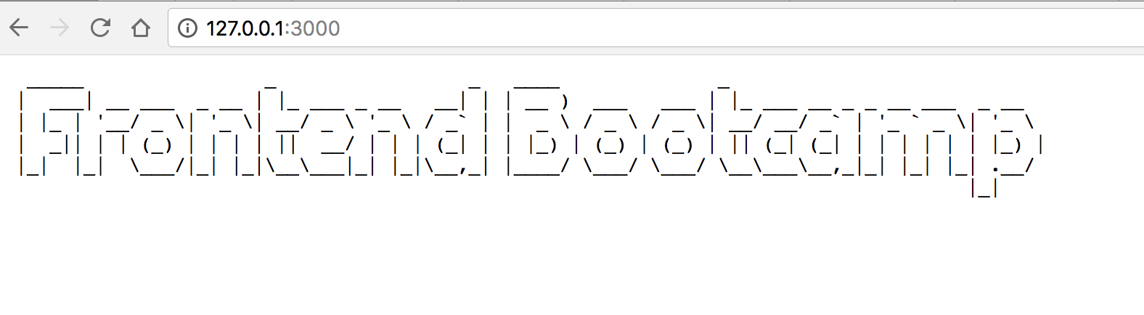

* You can use [figlet package](https://www.npmjs.com/package/figlet) to create ASCII font like this
* Keep in mind that your server.js file should contain only server logic and you should put your figlet text creation logic in separate file and require it in server.js file
* Pay attention that in node you need to use CommonJS for modules